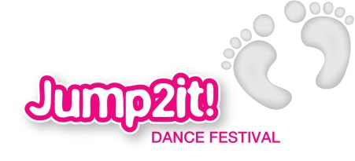

What to bring on SHOW day…

- Costume

- Props (if there are any)

- Plenty of water and healthy snacks

- Food for tea (ideally they need to have a hot dinner at school before they leave)

- Entertainment (eg book, cards, quiet games). It is strongly advised that they do not bring along expensive equipment as Loughborough Town Hall, South and North Charnwood School Sports Partnership, and Jumpstart into Primary School Dance cannot be held responsible for their safe keeping

